2 Corinthians

Defense of Apostolic Authority

Ministry Sincerity |  |  |  |  | Giving |  |  |  | Ministry Authority
Chapters 1–7 |  |  |  |  | Chapters 8–9 |  |  |  | Chapters 10–13
Defense of Paul’s  Motives |  |  |  |  | Defense of Paul’s  Worth |  |  |  | Defense of Paul’s  Traits
Character of Paul |  |  |  |  | Collection for Saints |  |  |  | Credentials of Paul
Greeting  1:1-11 | Defends Conduct  1:12–  2:17 | Defends Ministry  3:1–  6:10 | Restore Confi-  dence  6:11–  7:16 | Examples  8:1-9 |  | Purpose  8:10-15 | Arrange-  ments  8:16–  9:5 | Benefits  9:6-15 | Defense  10 | Offense  11:1–  12:18 | Warning  12:19–  13:10 | Closing  13:11-14
Macedonia

Fall AD 56

Key Word: Apostleship

Key Verse: “For we do not preach ourselves, but Jesus Christ as Lord, and ourselves as your servants for Jesus’ sake. For God, who said, ‘Let light shine out of darkness,’ made his light shine in our hearts to give us the light of the knowledge of the glory of God in the face of Christ” (2 Corinthians 4:5-6).

Summary Statement: The way the church should respond to God’s sincere care is to open their hearts to Paul, to Jerusalem saints, and to God himself.

Applications: Do you need to respond to God’s care in an area of your spiritual life that you have neglected?

For Church Lay People: Do you frequently criticize your spiritual leaders? (In other words, do you have a problem submitting to authority?)

For Spiritual Leaders: Are you fearful of defending your God-given spiritual authority?
2 Corinthians

Introduction

I. Title The earliest title for 2 Corinthians is Pro.j Korinqi,ouj b , (Second to the Corinthians). The b was obviously added later to distinguish this epistle from Paul's first letter to the same church.

II. Authorship

A. External Evidence: Even very creative critics uphold Paul as author as the patristic evidence is early. Early church writers upholding Paul include Polycarp (AD 105; To the Philippians 11), Irenaeus (AD 185; Against Heresies 4, 27, 45), and others, such as the Muratorian Fragment (2nd cent.).

B. Internal Evidence: The book argues strongly for Pauline authorship as it specifically claims to be written by Paul (1:1). Some critics have speculated that chapters 1–9 and 10–13 actually constitute two different letters (e.g., the letter of 2:4) because of their difference in tone (joy to concern and comfort to self-defense). However, the content of 10–13 never even mentions the offender of 2:5-11. Also, chapter 2 refers to a sorrowful tone that is lacking in the firm declarations of 10–13. Finally, no textual evidence, linguistic evidence, church fathers, or church tradition validates such an attack upon the unity of the book.

III. Circumstances

A. Date: Paul makes two comments concerning the Corinthians' giving which indicate that 2 Corinthians was written less than a year after 1 Corinthians (2 Cor 8:10; 9:2). That he was about to leave Ephesus (1 Cor 16:5-8) indicates that 1 Corinthians was written in May AD 56. The letter of 2 Corinthians followed later that year in fall AD 56.

B. Origin/Recipients: Paul addressed this second letter to the church at Corinth from the province of Macedonia that was north of Corinth.

C. Occasion: Paul's planting the Corinthian church on his second missionary journey took about eighteen months from March AD 51-September AD 52 (1 Cor 3:6, 10; 4:15; Acts 18:1-17). Nearly four years later while in Ephesus on his third missionary journey he received disturbing reports from Chloe’s household about divisions in the church (1 Cor 1:10) and a letter from the church carried by three men (1 Cor 16:17) that requested Paul's opinion on certain issues (1 Cor 7:1; 8:1; 12:1; 15:1; 16:1). He answered the problem of divisions and gave the much-needed response to the church's questions in the letter of 1 Corinthians (he had already written a letter before this; cf. 1 Cor 5:9).

However, within a year of Paul's writing 1 Corinthians, false teachers infiltrated the church (2 Cor 11:20) and stirred up the people against him by accusing him of being proud (2 Cor 10:1), fickle (2 Cor 1:16f.), unimpressive in appearance and speech (2 Cor 10:10), dishonest (2 Cor 8:16), and unqualified to be an apostle (2 Cor 11:23; 12:6-7). Paul saw this threat as valid reason to visit the church personally, and he refers to this second visit as a “painful visit” (2 Cor 2:1; 12:14; 13:1). He anticipates this visit in 1 Corinthians 16:5-9.

After leaving the church this second time, Paul wrote a sorrowful letter (his third letter to the church) to urge the church to discipline the leader of the opposition (2 Cor 2:1-11; 7:8f.). Titus delivered the letter then met Paul in Macedonia with the good news that most of the Corinthians had repented of rebelling against Paul's apostolic authority (2 Cor 7:6-7). Nevertheless, Paul still felt it necessary to write the letter of 2 Corinthians to defend himself against the minority opposition (2 Cor 10–13). So, Titus turned right around and headed back to Corinth to deliver 2 Corinthians, accompanied by two other brothers (2 Cor 8:16-24). Later Paul made a third visit to the church, anticipated in 2 Corinthians 13:1; Acts 19:21 and recorded in Acts 20:2-3.

IV. Characteristics (TTTB, 390, adapted)

A. This letter reveals Paul's character, motives, priorities, desires, and emotions more than any other NT writing. It notes events about Paul that would otherwise not be known: his persecutions and hardships not recorded in Acts (2 Cor 11:23-27), extra details of his escape from Damascus (11:32-33), God's revelation of Paradise to him in a vision (12:1-7), and his “thorn in the flesh” (12:7-10).

B. This is probably the least taught and least preached Pauline epistle in the church today. No doubt this is because pastors and teachers are reluctant to apply its message—that the church owes them respect because of their ministry for Christ full-time!

C. Second Corinthians is also probably Paul's most unsystematic epistle. The style is unique among Paul’s epistles in its many digressions, unusual constructions, mixed metaphors, broken sentences, and sudden shifts in feeling and tone. It has all the signs of having been written under extreme anguish of heart. Paul’s distress is that his entire eighteen-month's work at Corinth might be undermined by false teachers.

D. This letter expands upon Paul's former command for a contribution (1 Cor 16:1-4) in a passage offering the most extended teaching on giving in the New Testament (2 Cor 8–9).

Argument

Paul penned Second Corinthians to defend his apostolic authority against slanderous false teachers. This is accomplished by communicating the genuineness of his ministry so that the believers can really trust him (2 Cor 1–7) before they finish collecting the offering that they had pledged the year before (2 Cor 8–9), and through a defensive and offensive proclamation of the proofs of his apostleship (2 Cor 10–13). After investing eighteen months at Corinth, three letters, a painful visit and an anticipated visit, he was not about to let fake servants of Christ erode his foundation laid at Corinth. Therefore, this letter contains personal information necessary to uphold his integrity before the church so that it would not be lost to the enemy.

Synthesis

Defense of apostolic authority Answers allegations regarding:

1–7 Ministry sincerity Motives
1:1-11 Salutation
1:12–2:17 Defends conduct
1:12-24 Postponed visit
2:1-11 Disciplining opposer
2:12-17 Sending of Titus
3:1–6:10 Defends ministry
3 Superior to Mosaic
4:1–6:10 Suffering
6:11–7:16 Restore confidence

8–9 Giving Worth
8:1-9 Examples: Macedonians/Christ
8:10-15 Purpose
8:16–9:5 Arrangements
9:6-15 Benefits

10–13 Ministry authority
10 Defensive Traits
11:1–12:18 Offensive
11:1-6 Motive in making claims
11:7–12:18 Proofs of apostleship
12:19–13:10 Warning
13:11-14 Conclusion

Outline

Summary Statement for the Book
The way the church should respond to God’s sincere care is to open their hearts to Paul, to Jerusalem saints, and to God himself.

The church should respond to God’s sincere care for them by opening their hearts to Paul (2 Cor 1–7).

God comforted Paul while fleeing Asia, so they should support and pray for him (1:1-11).

God worked in Paul’s postponed visit and discipline of their sinning leader (1:12–2:17).

His postponed visit when they doubted his care actually prevented Paul from overly rebuking them for not disciplining their leader who opposed Paul (1:12-24).

Their discipline of this leader should make Paul’s next visit a positive one so that Satan would not drive a wedge between Paul, this leader, and the church (2:1-11).

Instead of returning, Paul’s sending Titus will remind them to spread the sweet aroma of Christ to believers and warn unbelievers of their impending peril (2:12-17).

Paul’s new covenant ministry—not the false teachers—blessed Corinth (3:1–6:10).

His ministry is even greater than Moses's since the glory of the new covenant is greater than that of the Mosaic covenant (2 Cor 3).

He does not lose heart in suffering since he sees his trials from God's perspective (4:1–6:10).

Paul never gives up during suffering because God's power helps him to minister for their benefit (4:1-15).

Paul retains courage in suffering because his motivation comes from an eternal view and a love that compels him in his ministry of reconciliation (4:16–6:2).

Paul marks of a genuine ministry in his suffering does not discredit his ministry through offending others by requiring a comfortable lifestyle (6:3-10).

They should open their hearts to him—not to unbelievers—as he did to them (6:11–7:16).

The church should respond to God’s sincere care for them by generously giving to the distressed Jerusalem saints (2 Cor 8–9).

The Macedonians and Jesus gave selflessly so the richer Corinthians should too (8:1-9).

Giving helps all churches equally carry on their ministries in their times of need (8:10-15).

Paul’s advance team will help them prove their generosity in giving (8:16–9:5).

Generosity blesses the givers and causes the recipients to thank God (9:6-15).

The church should respond to God’s sincere care for them by submitting to God’s authority (2 Cor 10–13).

Paul was an apostle though some thought him timid, weak, and proud (2 Cor 10).

Paul proved was an apostle so the church wouldn’t be deceived (11:1–12:18).

His motive in making the following apostolic claims is to assure with a godly jealousy that the Corinthians not be deceived (11:1-6).

He proves his claim to be a genuine apostle of Christ (11:7–12:18).

His willingness to minister without pay supports his apostleship (11:7-15).

His sufferings support his apostleship (11:16-33).

His visions and revelations, especially his revelation of Paradise that necessitated a thorn in the flesh, supports his apostleship (12:1-10).

His miraculous signs and wonders support his apostleship (12:11-12).

His paternal love for the church supports his apostleship (12:13-18).

They must repent to show they submit to God’s authority (12:19–13:10).

They must love each other to show submit to God’s authority (13:11-14).

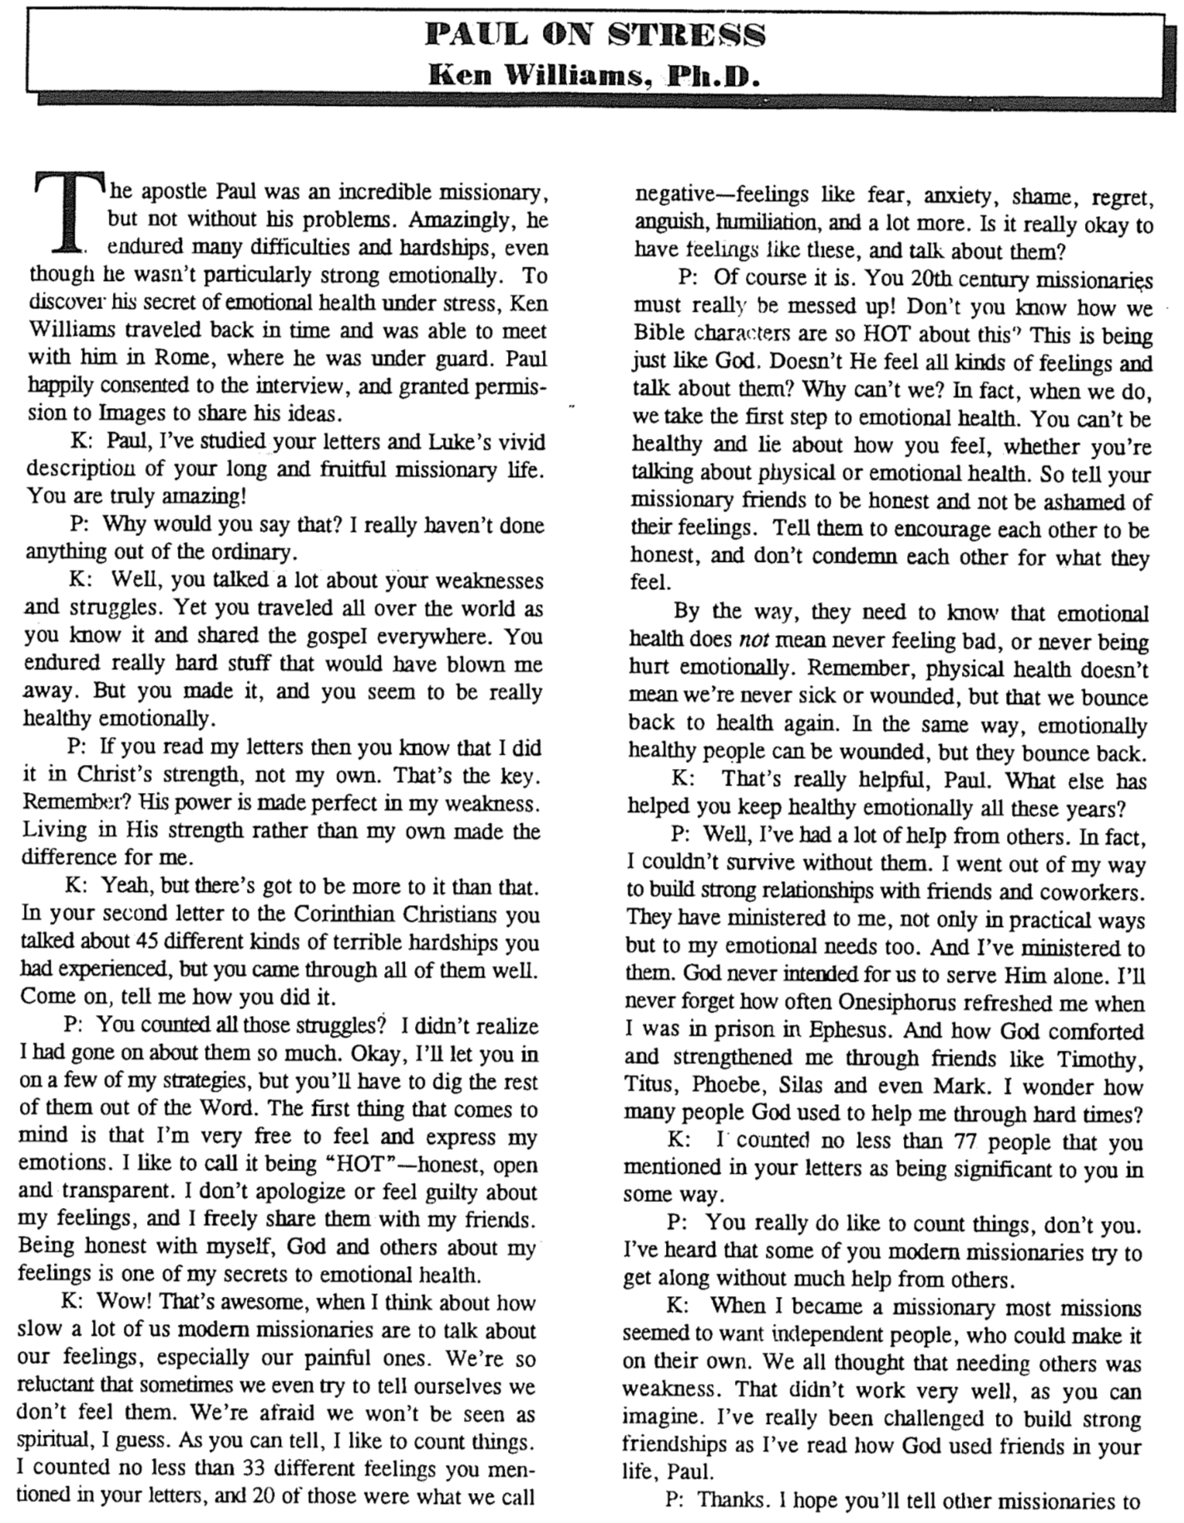
Paul on Stress
(1 of 2)

Paul on Stress (2 of 2)

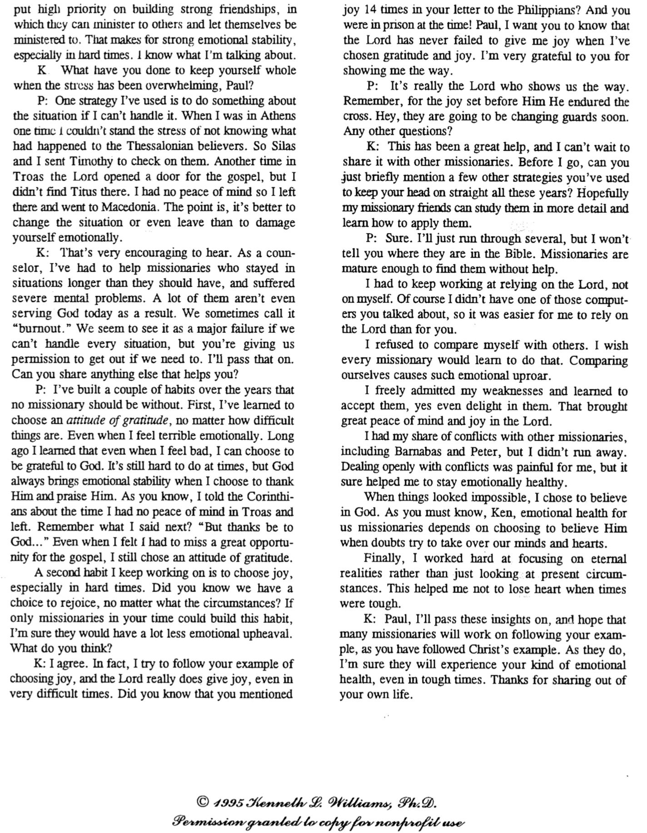
Contrasting the Old and New Covenants
2 Corinthians 3–4

Old Covenant | New Covenant
initiated by Moses (3:8) | initiated by Christ (3:4)
of the letter (3:6a) | of the Spirit (3:6a, 18b)
kills (3:6b, 7a) | gives life (3:6b)
engraved on stone (3:3b, 7a) | engraved on hearts (3:3b; Jer. 31:33)
glorious (3:7a) | more glorious (3:8, 10)
glory faded (3:7b, 11a, 13b) | glory ever-increases (3:11b, 18)
condemns men (3:9a) | brings righteousness (3:9b)
deception (3:13) | boldness (3:12)
veiled face of Moses (3:13b) | unveiled faces (3:13a, 18a)
veiled minds (3:14a) | unveiled minds (3:14b; 4:3-6)
veiled hearts (3:15) | unveiled hearts (3:16)
dullness (3:14a) | freedom (3:17)
Moses reflected God’s glory | all believers reflect Christ’s glory (3:17)
non-transforming (3:7) | transforming (3:18)
lack of zeal (3:13) | confidence, steadfastness (3:4-5; 4:1)
deception (3:13) | sincerity (4:2)

Views on the New Covenant

Issue: How can the OT and NT data on the New Covenant be reconciled? Jeremiah 31 declares it is for Israel and Judah but the NT (Luke 22:20; 1 Cor 11:25; 2 Cor 3:6; Heb. 8:8; 9:15) apply it to the church. Is there actually no New Covenant, is it only for Israel or only for the church, or are there two New Covenants, or does the church participate in some of its aspects while awaiting the final fulfillment of the covenant? This study takes the last view, as do most modern premillennialists and other scholars. Note that “OC” and “NC” below relate to the Old Covenant and New Covenant, respectively.

View | Explanation | Theology & Scholars | Problems
Restated Mosaic | No New Covenant | Critical:  –Couturier  –Duhm  –Schmidt  –Potter | 1. OC/NC distinctions in text ignored  2. OC=conditional, NC=unconditional  3. OC=temporal, NC=eternal  4. OC=external, NC=internal  5. OC=no enablement, NC=enablement  6. NC=peace, prosperity, sanctuary, Spirit  (parallel passages)
Church Alone | No Israel Participation | Amillennial/  Postmillennial:  –Allis  –Cox  –Smick  –Boettner | 1. Ignores OT data by equating Israel & the Church  2. NC introduced ≠ fulfilled to Israel  3. Present need to know YHWH (still need the Great Commission)  4. AD 70 Jerusalem vs. Jer. 31:40
Israel Alone | No Church Participation | Misc/Classical Dispensational:  –Darby  – Thompson  –von Rad | 1. Ignores NT data  –Christ's Last Supper words  –Paul's statements  –Hebrews application to Church  2. Ignores present work of Spirit
Two New Covenants | NC for Israel  +  NC for Church | Early 1900s Dispensational:  –Chafer  –Walvoord (old)  –Ryrie (old) | 1. Same terminology for OT & NT NCs  2. Israel/Church distinction too sharp  3. Basis of forgiveness the same  4. If 2 NCs then no OC for Church  5. Church doesn’t possess Israel's promises
Church Participation | Primarily for Israel  Secondarily for the Church | Misc/Present Dispensational:  –Keil  –Lemke  –Bright  –Scofield  –Walvoord (DTS)  –Ryrie (DTS)  –Archer (TEDS)  –Kaiser (TEDS) | Support:  1. Primary fulfillment future–Rom 11  2. Deals with both OT & NT data  3. Forgiveness/Spirit=blessings now  4. NC has new law  5. Rebuttals to above views

Signs of the Covenants

God has made several covenants with man throughout the ages. With several of them he has attached a sign or memorial as reminders of his and/or our responsibilities to keep these covenants.

Covenant | Definition | Promise | Fulfillment | Sign
Noahic | Unconditional promise not to flood the earth again | Gen. 9:12-17 | No more sea  (Rev. 21:1) | Rainbow  (Gen. 9:12-17)
Abrahamic | Promise to provide Israel a land, rule, and spiritual blessing | Gen. 12:1-3; 15:13-18 | Continues at present (Gal. 3:17) but Israel still has a future (see Rom. 11:25-27) | Circumcision  (Gen. 17:11)
Mosaic | Conditional stipulations for blessing on Israel | Exod. 19–31; Deut. 28 | Death of Christ (Rom. 7:4-6) | Sabbath  (Exod. 31:13)
Land | Promise of physical land from the Wadi of Egypt to the River Euphrates | Deut. 30:1-10 | Land blessed (Amos 9:13-15) | No sign  (that I know of)
Davidic | Promise of eternal,  political rule of a descendant of David | 2 Sam. 7:12-17 | Rule renewed (Amos 9:11-12) | Christ seated at the Father’s right hand  (Acts 2:34-36)
New | Promise of spiritual indwelling of the Spirit (“law written on hearts”), forgiveness, and total evangelization of Israel | Jer. 31:31-34 | Paul & the Apostles (2 Cor 3–4)  All Israel saved (Rom. 11:26-27) | Cup of the Lord’s Supper (Luke 22:20; 1 Cor 11:25)

